Pain MANAGEMENT RATING Scale and tracking Calendar

Patient: Date:

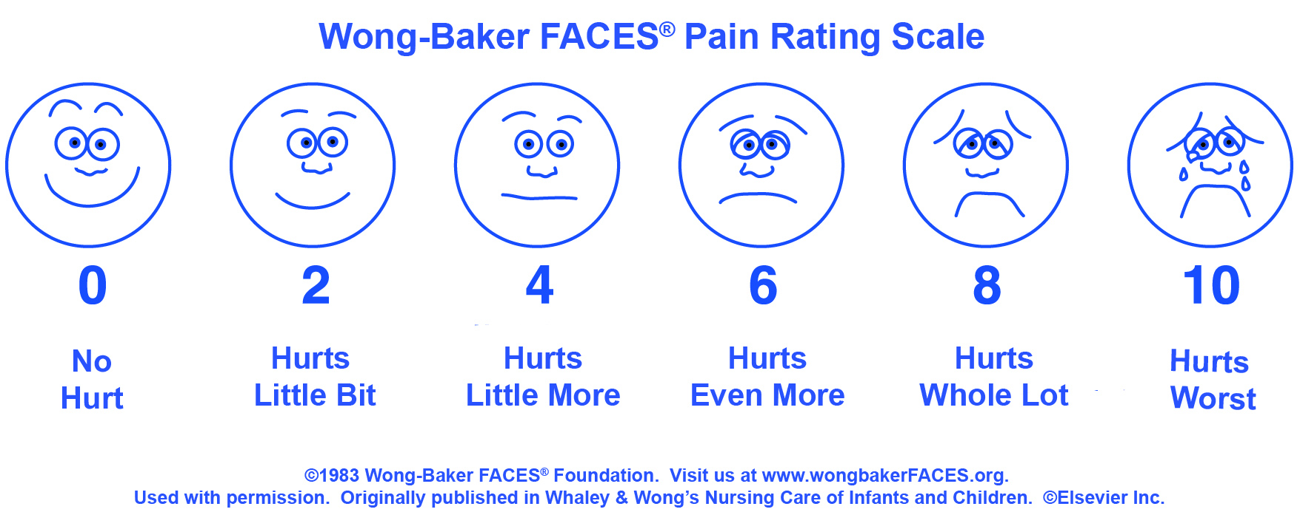

Tips:
- Choose the face that best depicts the pain you are experiencing (see Wong-Baker FACES Pain Rating Scale to the right).
- Make notes about your pain levels and on the pain intervention taken (what you did or what medication you took) and its effectiveness.
- Take time to notice daily and weekly improvements (even small ones), they add up.

DATE | TIME | PAIN RATING | Pain Intervention Taken (Medication or supplement and dosage  and/or other technique such as meditation or exercise.) | Side Effect(s) | Effectiveness

Successful Surgery and Healing: A Practical Guide for Patients, Caregivers and Advocates, lorimertz.com,160318

DATE | TIME | PAIN RATING | Pain Intervention Taken (Medication or supplement and dosage  and/or other technique such as meditation or exercise.) | Side Effect(s) | Effectiveness

Successful Surgery and Healing, lorimertz.com, 052715

